**Lesson 11 Demo 3**

**Implementing the Local-Exec Provisioners**

|  |
| --- |
| **Objective:** To implement the Local-Exec Provisioners    **Prerequisites:** You need to have Python 2.7 or higher, minimum 8 GB RAM, and SSH or SCP communicator.    **Tools required:** Ubuntu terminal |

**Steps to be followed:**

1. Downloading the appropriate package
2. Adding the binary file into the bin directory
3. Using local-exec provisioners
4. Initializing terraform
5. Running our deployment and passing our variable

**Step 1: Downloading the appropriate package**

1. Click on the URL given below and install the package suitable for your OS (For lab you can click on 64-bit Linux):

<https://www.terraform.io/downloads.html>

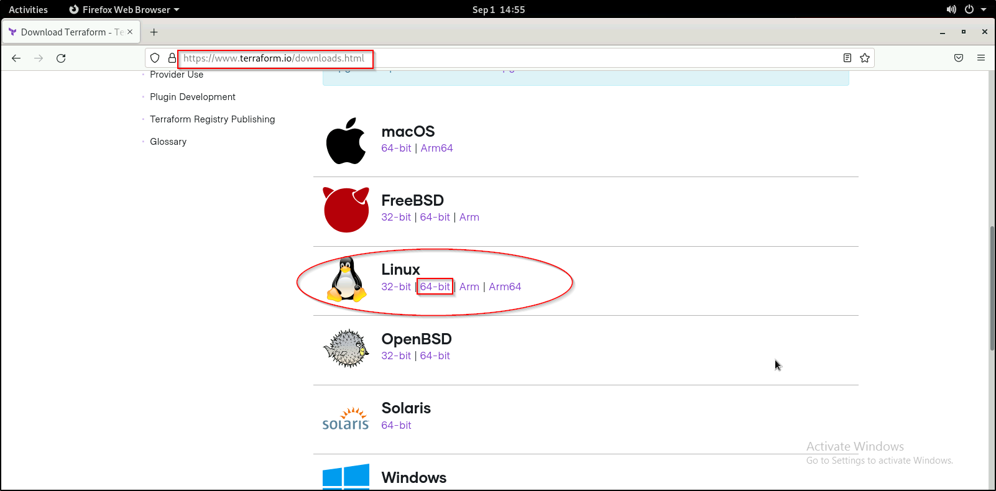

**Step 2: Adding the binary file into the bin directory**

1. Run the below set of commands to unzip and move the Terraform binary file to the bin directory:

***cd Downloads***

***ls***

***unzip <YourTerraformFileName>.zip***

***sudo mv terraform /usr/local/bin***

***cd ..***

1. You can verify the terraform installation using the command given below:

***terraform -version***



**Step 3: Using terraform local-exec provisioners**

3.1 Use the following command to setup **main.tf**:

***sudo nano main.tf***



* 1. Add the following code in **main.tf**:

***resource "null_resource" "this" {***

***provisioner "local-exec" {***

***command = "echo ${var.owner} > file_${null_resource.this.id}.txt"***

***}***

***}***

Press Ctrl+x and then press Y for yes.



Press enter to save the file.

* 1. Use the following command to setup **variables.tf**:

***sudo nano variable.tf***



* 1. Add the following line in **variables.tf**:

***variable "owner" {}***

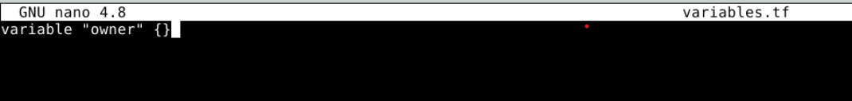

Press Ctrl+X and then press Y for yes.

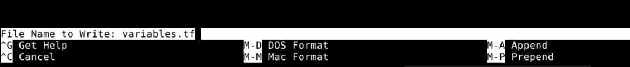

Press enter to save the file.

**Step 4: Initializing Terraform**

4.1 Use the following command to initialize terraform as terraform builds up a dependency tree from all the .tf file and downloads any dependencies it requires:

***terraform init***

**Step 5: Running our deployment and passing our variable**

5.1 Use the following command to run the deployment and pass our variable at runtime:

***terraform apply -var 'owner=aasthajainsimpl' -auto-approve***

|  |
| --- |
| **Note**: You will have to replace owner with your node’s username and copy your unique ID. |

5.2 Use the following command view the written file:

***cat file_2112920878954479684.txt***



|  |
| --- |
| **Note**: You will have to replace the id with your unique ID that you copied in previous step. |